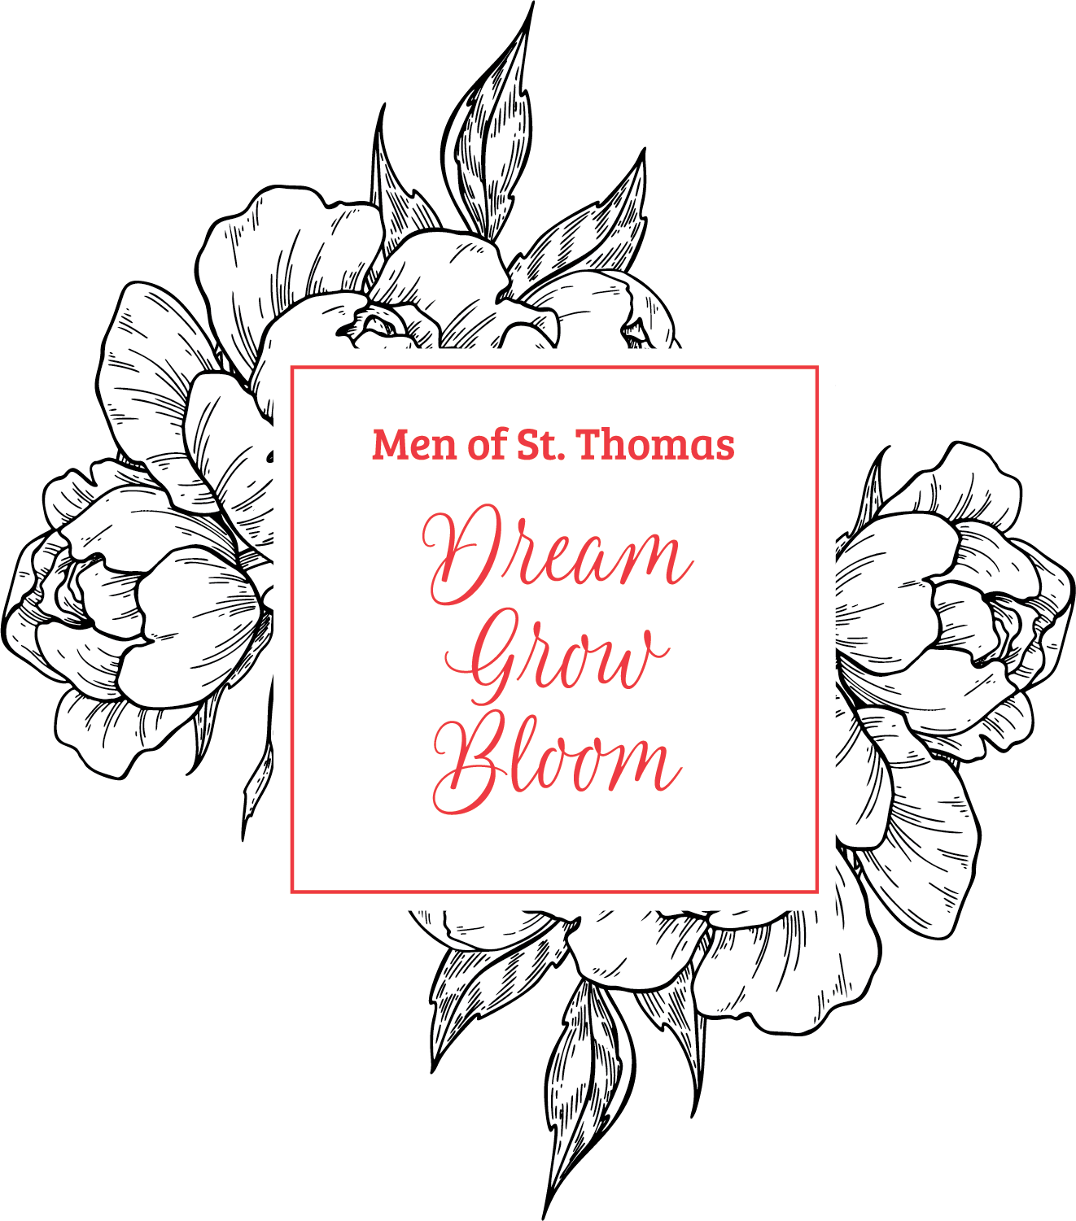
SAVE THE DATE for Style Show’s
SHOPPING SPREE
THURSDAY, MARCH 21ST IN MARY MOODY
9:30 a.m. to 3:30 p.m.
Benefiting STH Style Show Mystery Bags
Great place to shop for presents for Easter, Mother’s Day, your family & friends plus treat yourself!!!
Help us “stuff” our bags with anything you would want to receive,
gift cards, wines, champagne, liquor, facial/body spa products, etc.
&/or purchase items from vendors to donate!
Vendors include: Aspire + Blanche’ + Ms. Ishi's Kitchen + Angel's Delight + DGZ chocolates + Dorie Kerr Jewelry + India Hicks + Shannon Weir Modern Art & Interiors + Gingersnaps + Rodan & Fields + Jolie V Official + Shopaholic Sanctuary + Brenham Kitchen + Maria Victoria + Author Valerie Sweeten + more to come!

