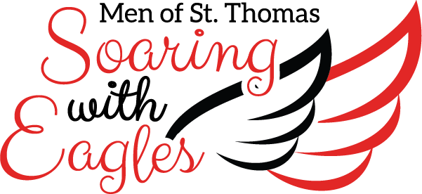

Dear Friend of St. Thomas,

The St. Thomas High School Mothers’ Club will host the 49th annual Style Show,
Men of St. Thomas…Soaring with Eagles on Friday, April 24, 2020, at River Oaks Country Club. The style show and luncheon will honor the Class of 2020.

Mystery Bags will be sold at this event. All proceeds will benefit the current and future men of St. Thomas. We are currently seeking donations of gift cards and items to include in the mystery bags. To be recognized in the program, please fill out and return the enclosed donation form by Wednesday, April 8, 2020.

There are three ways to return a completed donation form:

- Mail it to St. Thomas High School
4500 Memorial Drive
Houston, Texas, 77007
Attn: Advancement Office | Style Show
- Fax it to 713.864.5750, Attn: Advancement Office | Style Show
- To arrange a pick up or questions, contact Paola Ballesca paoballesca@gmail.com or Catherine Chandler catherine.chandler@sths.org.

Thank you in advance for supporting this year’s style show and luncheon, Men of
St.Thomas…Soaring with Eagles, to benefit the current and future men of
St. Thomas. Your generosity is greatly appreciated.

Come Soar with us, 2020 Style Show Chairs

Holly Schlosser Dena Skucius
hollystyleshow@gmail.com cjskucius@sbcglobal.net

